EXPERIMENT 9

VIEWS

CREATE TABLE STUDENT WITH ATTRIBUTES ID,NAME AND DEPARTMENT.

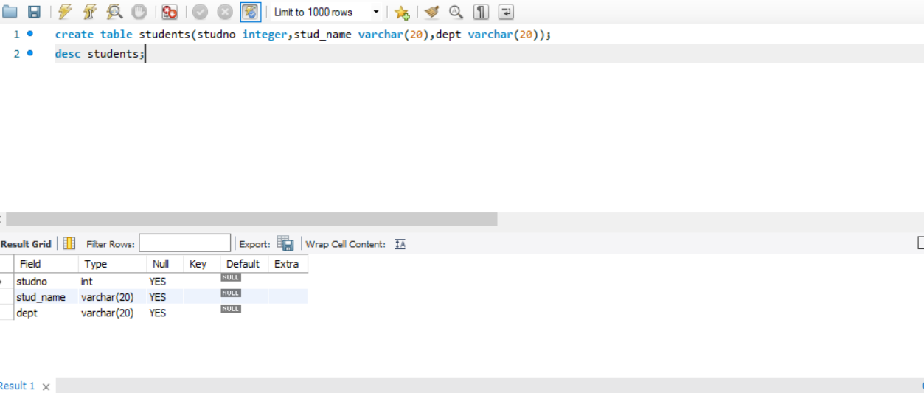

Display



Create view and select

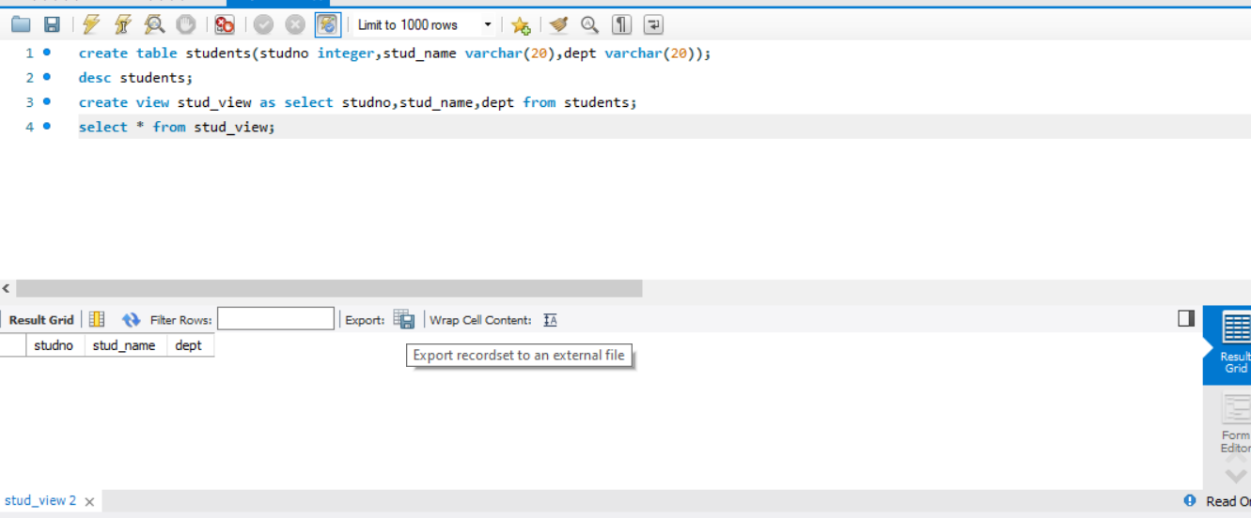

Insert values

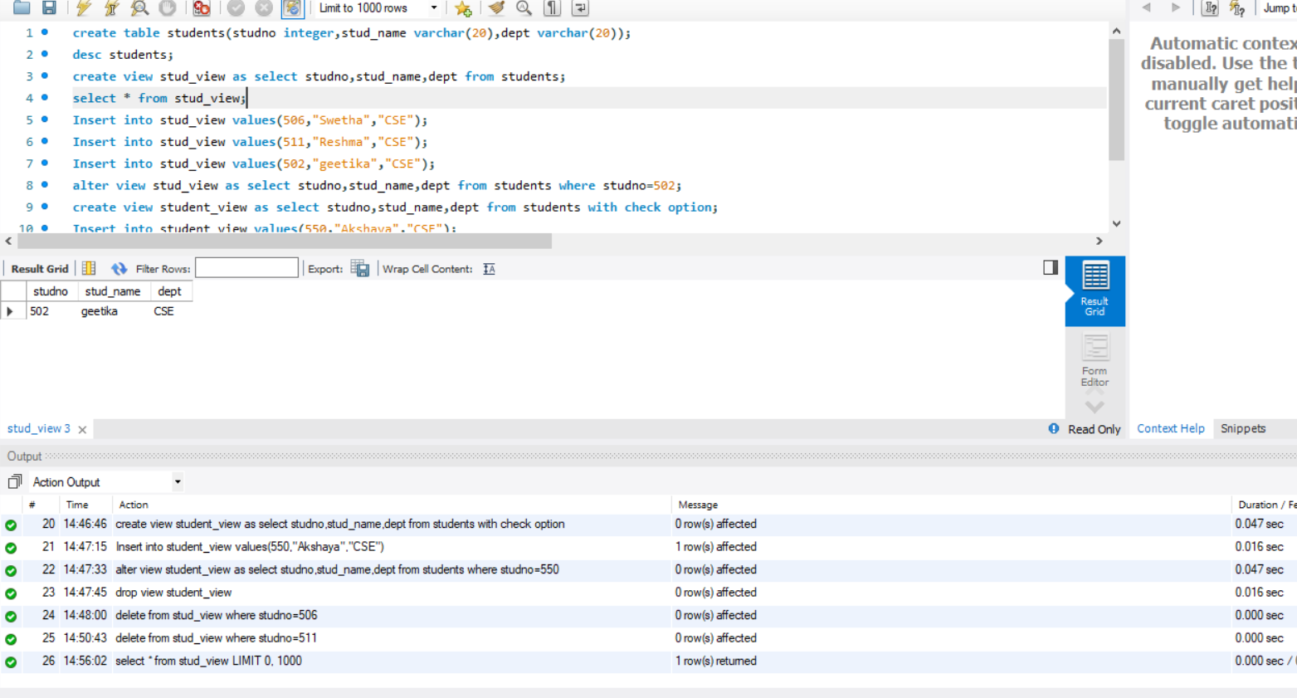

Alter table

